## modulettes table

## Fields

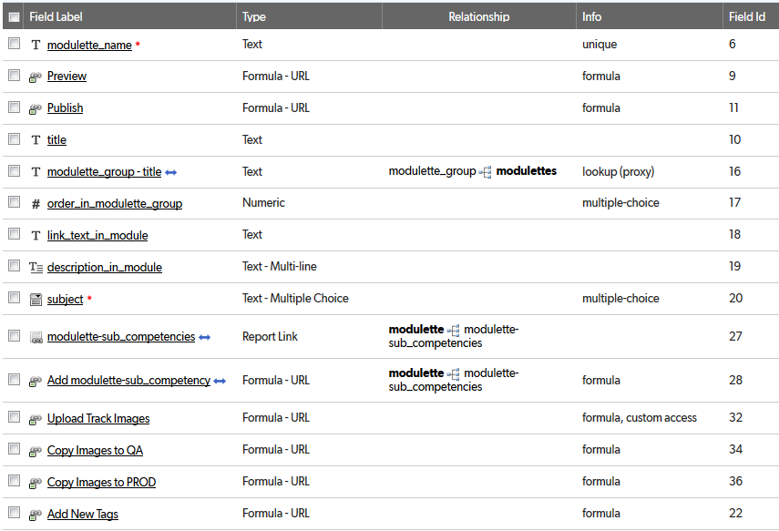

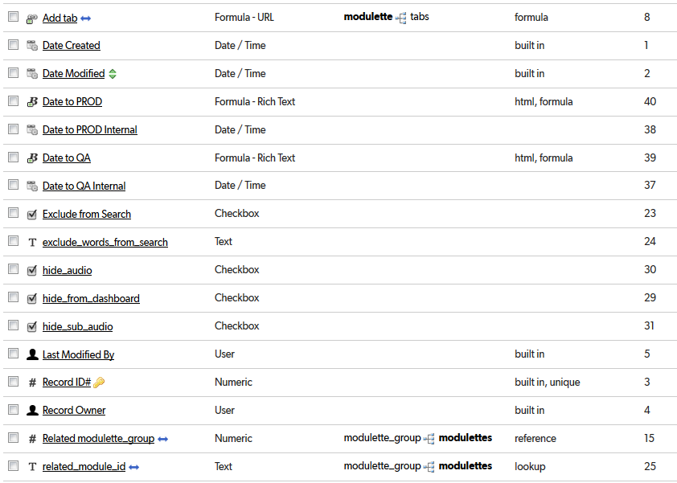

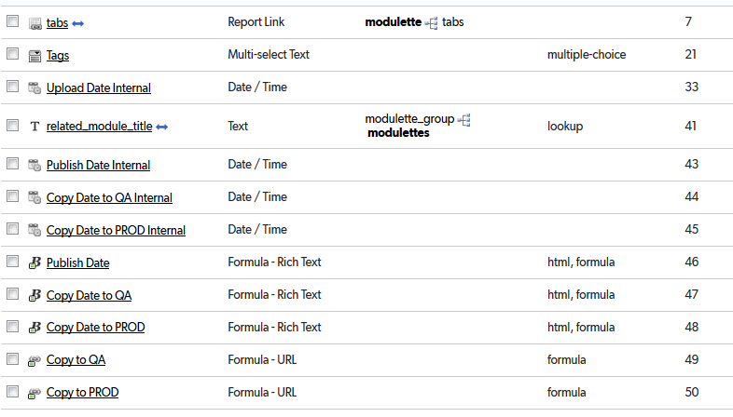

## Relationships

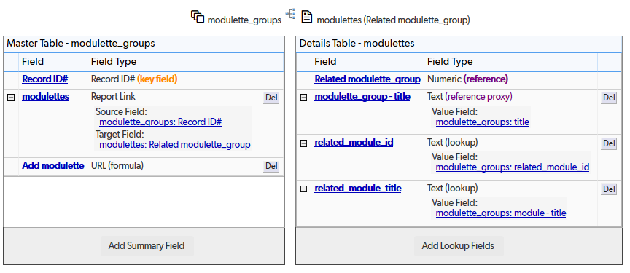

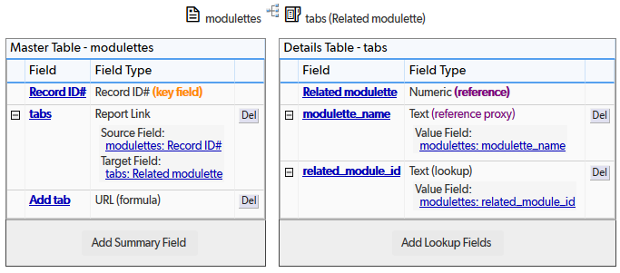

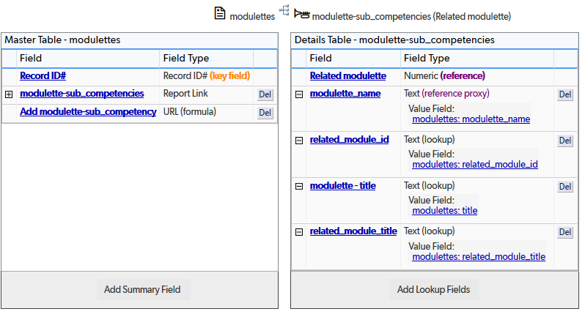

## Field settings

Note: Built-in fields use the default settings

modulette_name 6

Preview 7

Publish 8

title 9

modulette_group – title 10

order_in_modulette_group 11

link_text_in_module 13

description_in_module 14

subject 15

modulette-sub_competencies 17

Add modulette-sub_competency 18

Upload Track Images 19

Copy Images to QA 20

Copy Images to PROD 21

Add New Tags 22

Add tab 23

Date to PROD 24

Date to PROD Internal 25

Date to QA 26

Date to QA Internal 27

Exclude from Search 28

exclude_words_from_search 29

hide_audio 30

hide_from_dashboard 31

hide_sub_audio 32

Related modulette_group 33

related_module_id 35

tabs 36

Tags 37

Upload Date Internal 38

related_module_title 39

Publish Date Internal 40

Copy Date to QA Internal 41

Copy Date to PROD Internal 42

Publish Date 43

Copy Date to QA 43

Copy Date to PROD 44

Copy to QA 45

Copy to PROD 46

# modulette_name

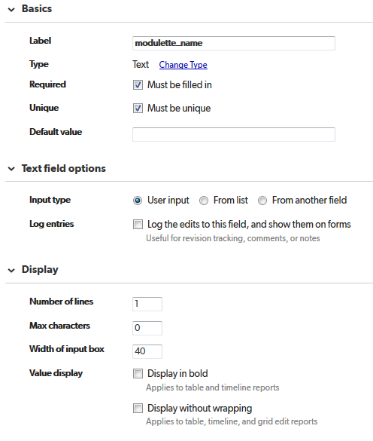

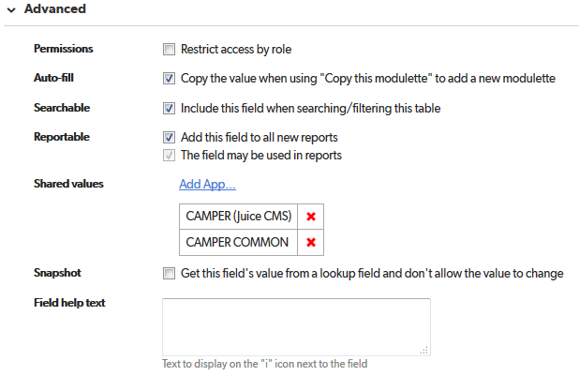

# Preview

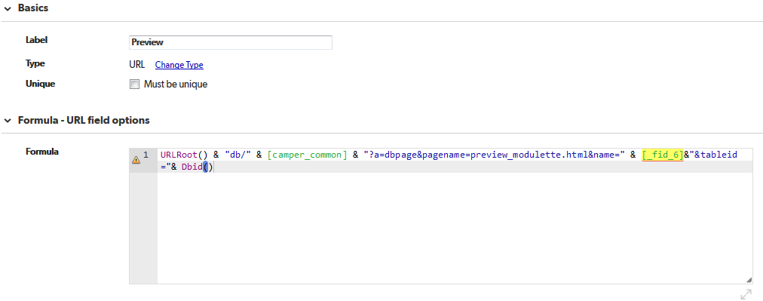

URLRoot() & "db/" & [camper_common] & "?a=dbpage&pagename=preview_modulette.html&name=" & [_fid_6]&"&tableid="& Dbid()

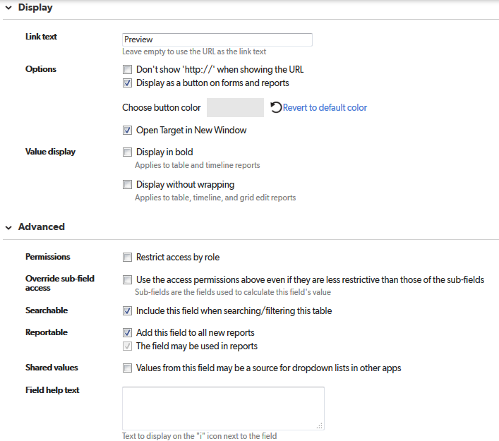

# Publish

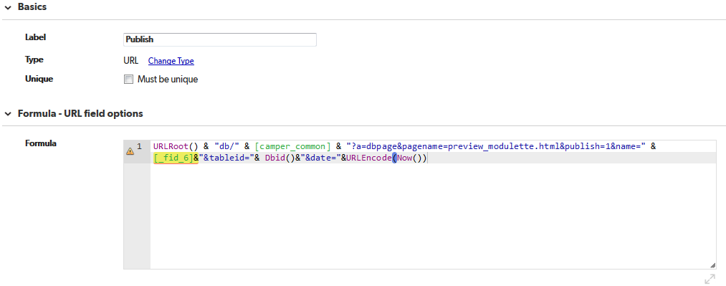

URLRoot() & "db/" & [camper_common] & "?a=dbpage&pagename=preview_modulette.html&publish=1&name=" & [_fid_6]&"&tableid="& Dbid()&"&date="&URLEncode(Now())

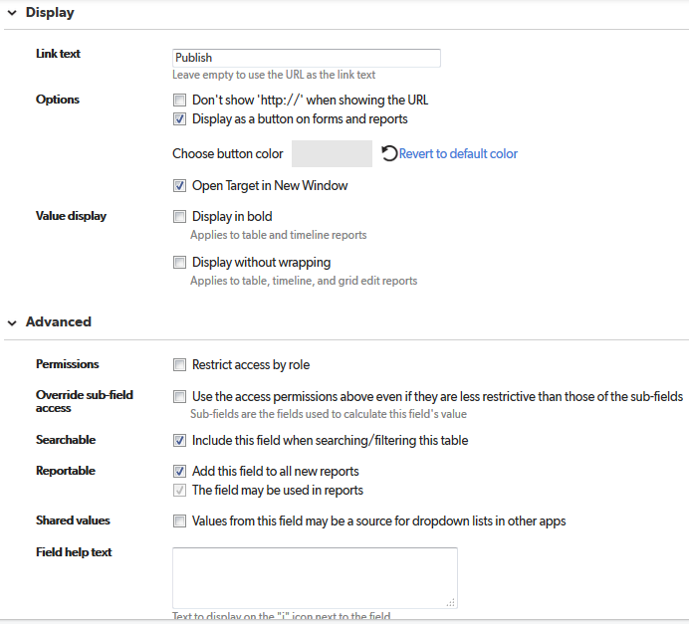

# title

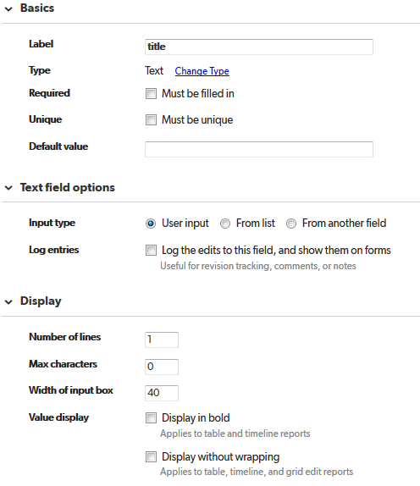

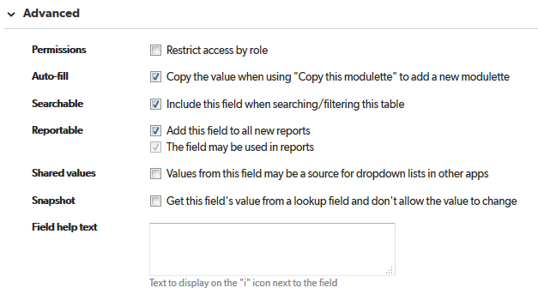

# modulette_group – title

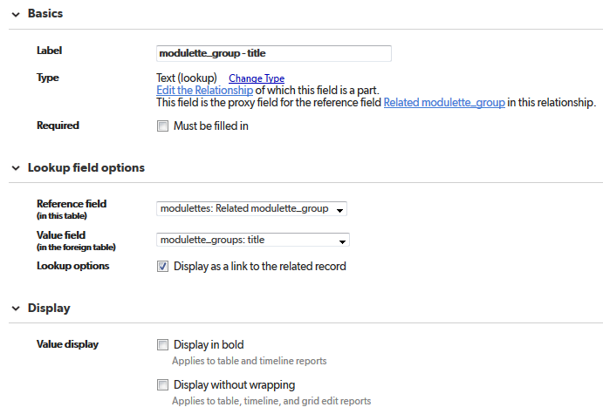

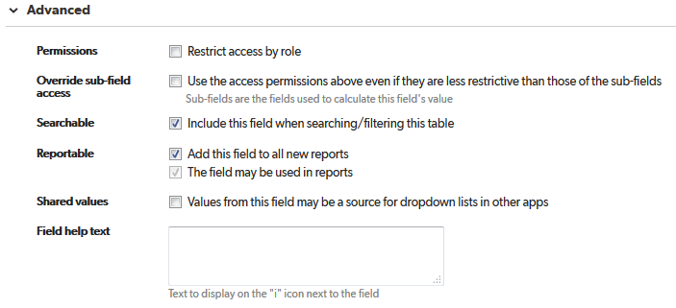

# order_in_modulette_group

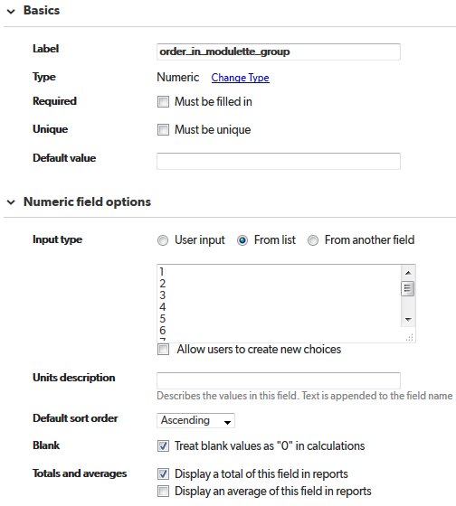

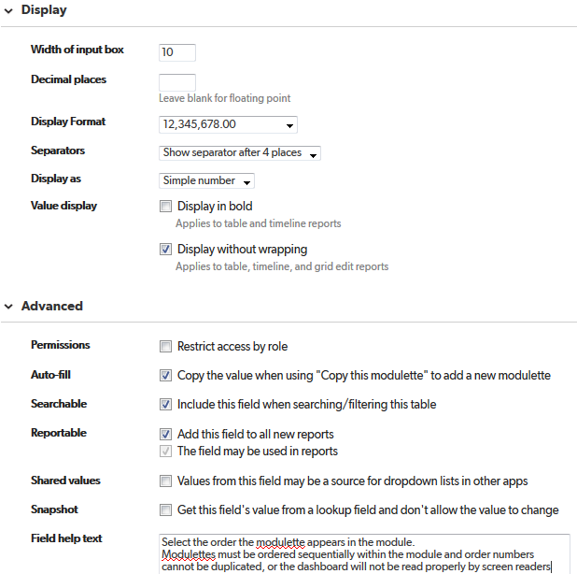

# link_text_in_module

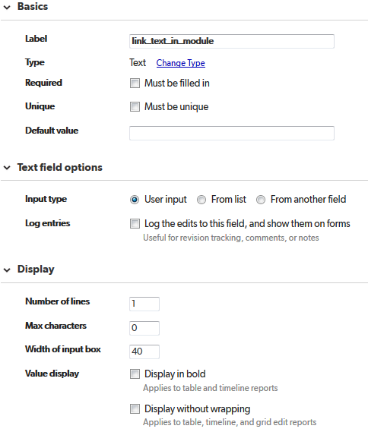

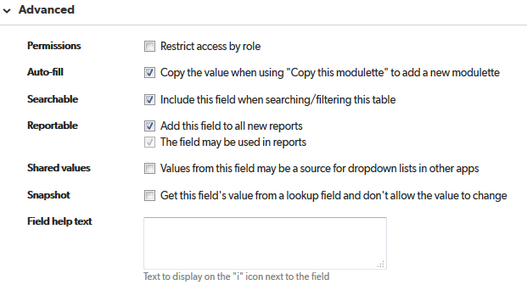

# description_in_module

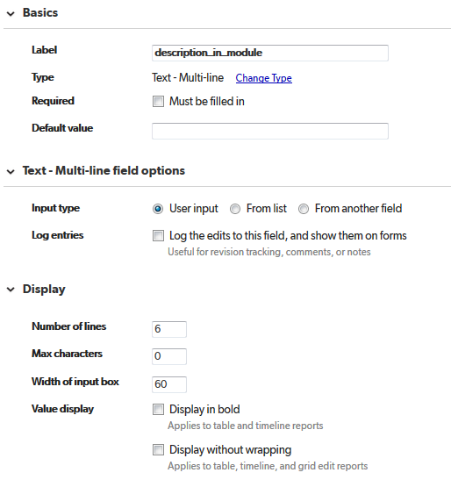

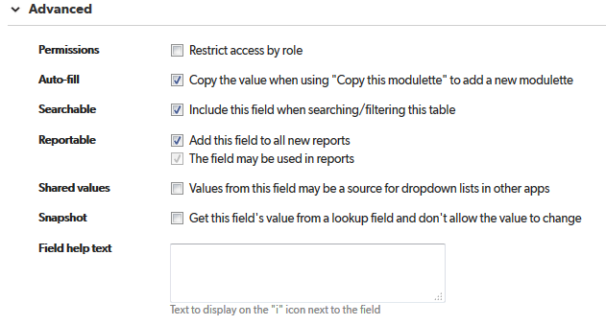

# subject

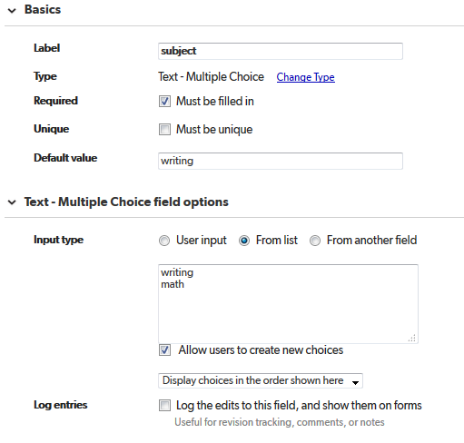

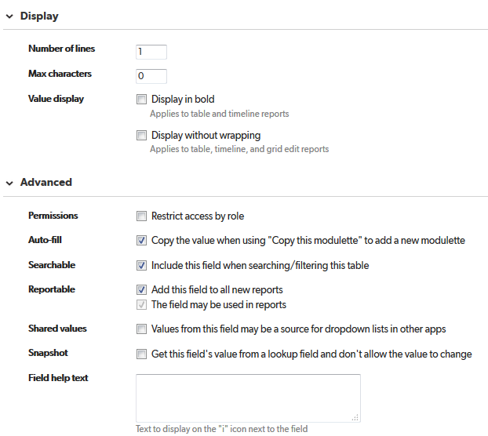

# modulette-sub_competencies

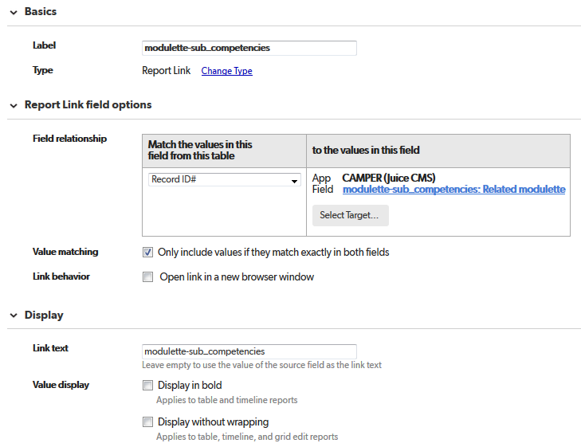

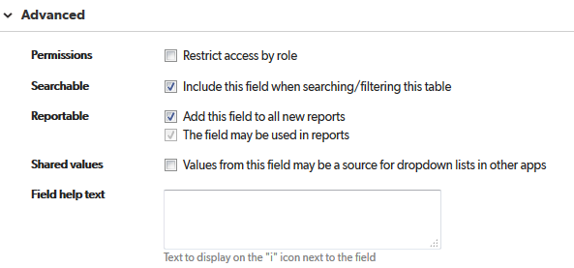

# Add modulette-sub_competency

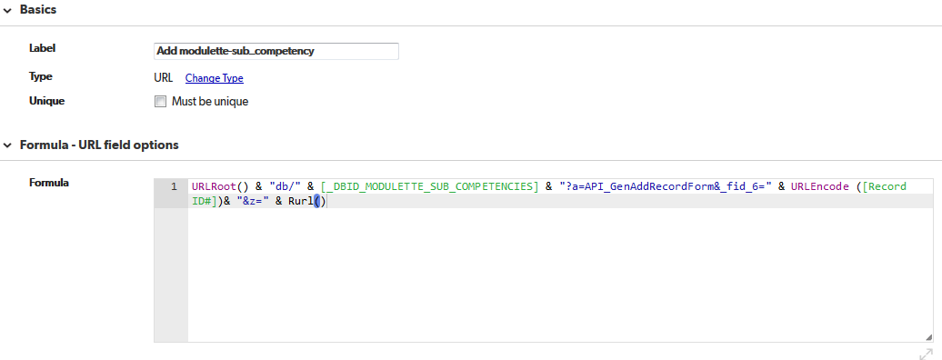

URLRoot() & "db/" & [_DBID_MODULETTE_SUB_COMPETENCIES] & "?a=API_GenAddRecordForm&_fid_6=" & URLEncode ([Record ID#])& "&z=" & Rurl()

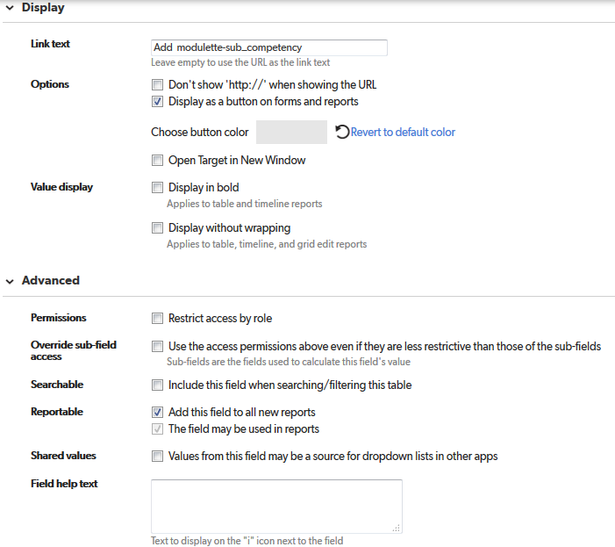

# Upload Track Images

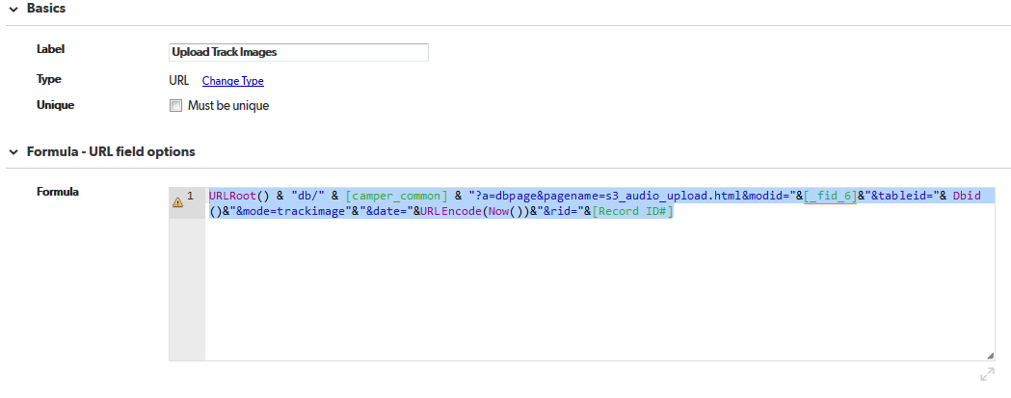

URLRoot() & "db/" & [camper_common] & "?a=dbpage&pagename=s3_audio_upload.html&modid="&[_fid_6]&"&tableid="& Dbid()&"&mode=trackimage"&"&date="&URLEncode(Now())&"&rid="&[Record ID#]

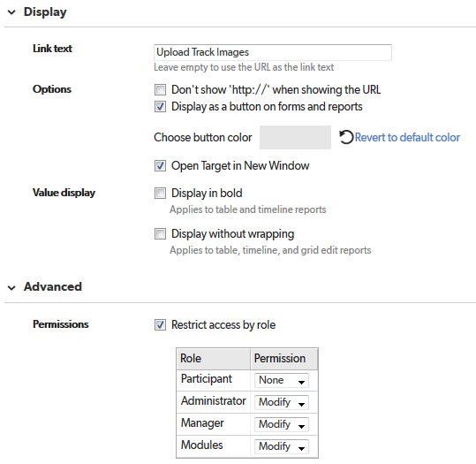

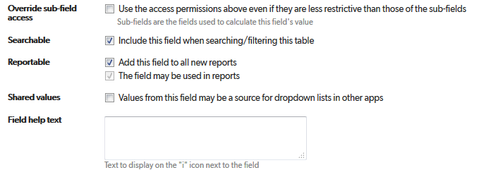

# Copy Images to QA

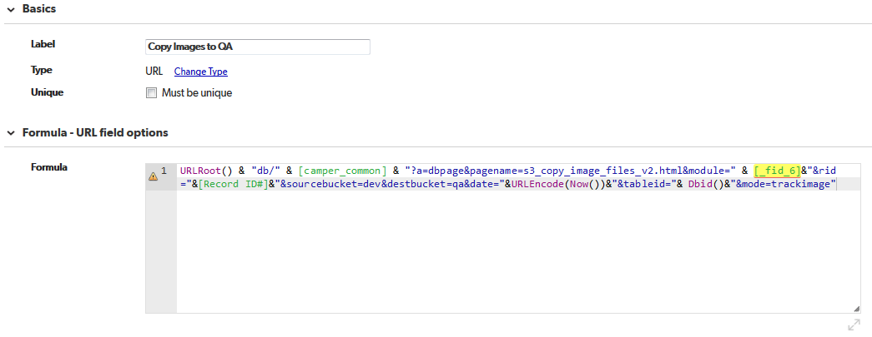

URLRoot() & "db/" & [camper_common] & "?a=dbpage&pagename=s3_copy_image_files_v2.html&module=" & [_fid_6]&"&rid="&[Record ID#]&"&sourcebucket=dev&destbucket=qa&date="&URLEncode(Now())&"&tableid="& Dbid()&"&mode=trackimage"

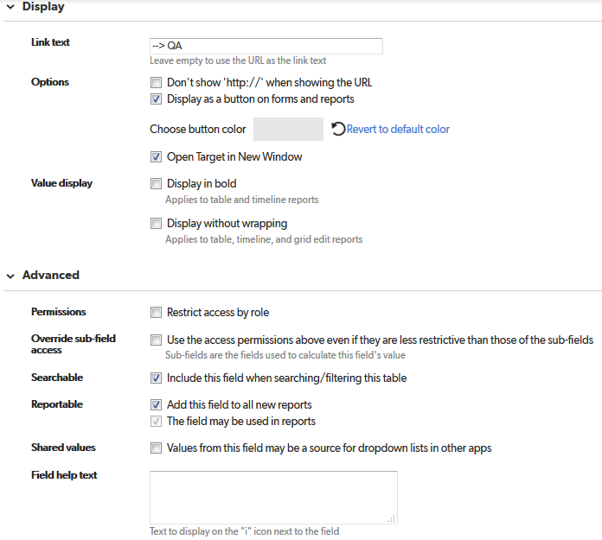

# Copy Images to PROD

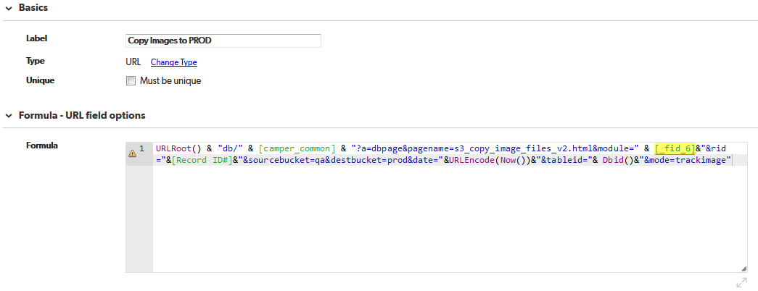

URLRoot() & "db/" & [camper_common] & "?a=dbpage&pagename=s3_copy_image_files_v2.html&module=" & [_fid_6]&"&rid="&[Record ID#]&"&sourcebucket=qa&destbucket=prod&date="&URLEncode(Now())&"&tableid="& Dbid()&"&mode=trackimage"

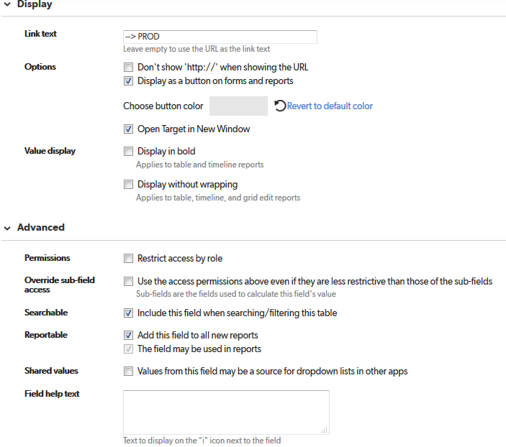

# Add New Tags

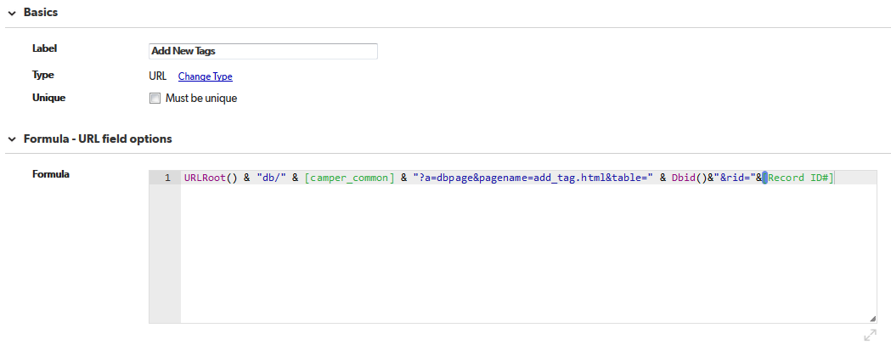

URLRoot() & "db/" & [camper_common] & "?a=dbpage&pagename=add_tag.html&table=" & Dbid()&"&rid="&[Record ID#]

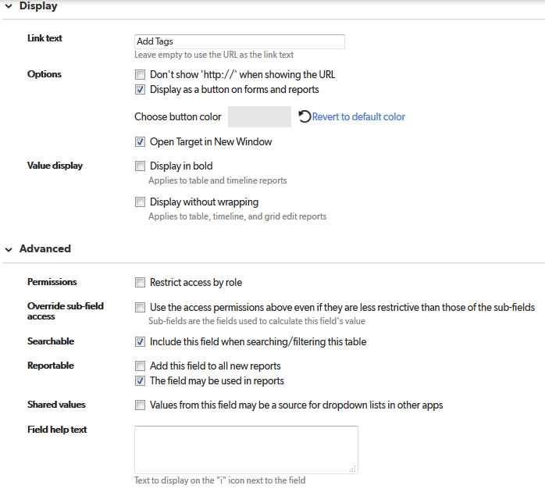

# Add tab

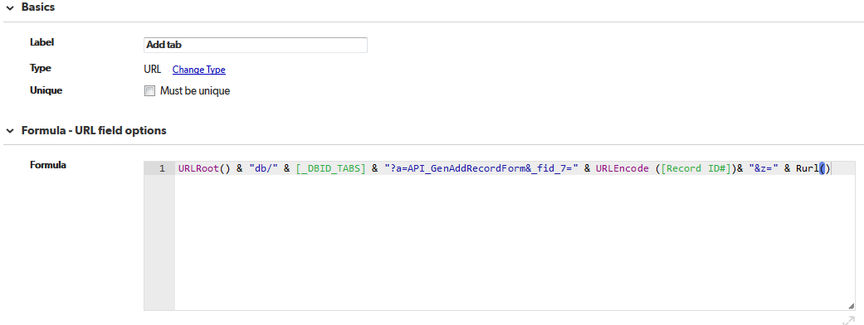

URLRoot() & "db/" & [_DBID_TABS] & "?a=API_GenAddRecordForm&_fid_7=" & URLEncode ([Record ID#])& "&z=" & Rurl()

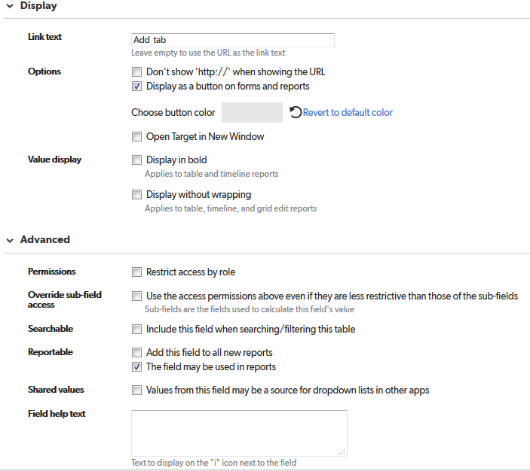

# 

# Date to PROD

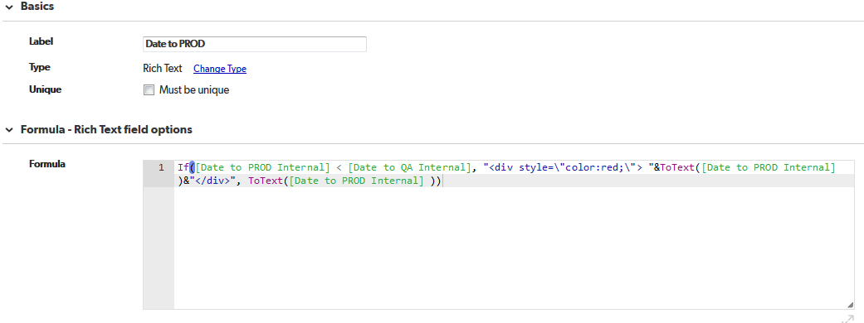

If([Date to PROD Internal] < [Date to QA Internal], "<div style=\"color:red;\"> "&ToText([Date to PROD Internal] )&"</div>", ToText([Date to PROD Internal] ))

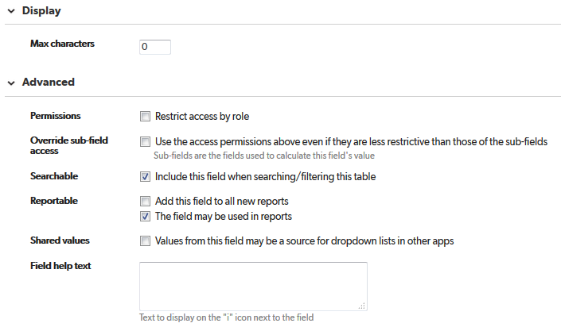

# Date to PROD Internal

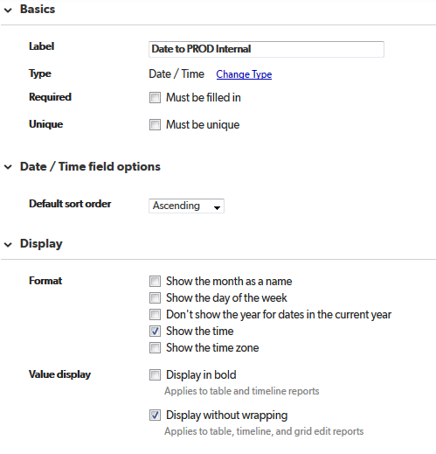

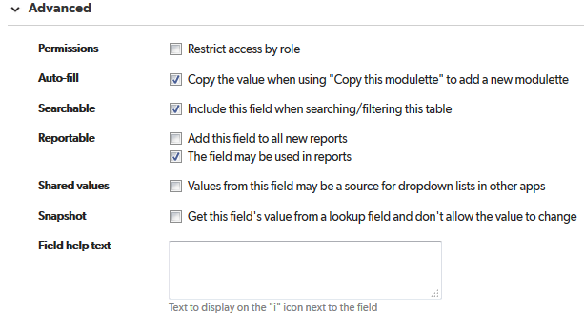

# Date to QA

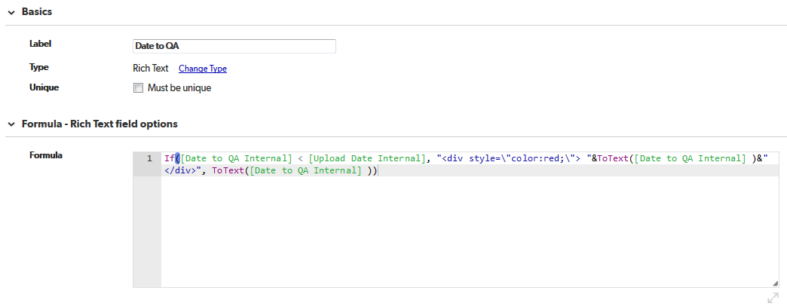

If([Date to QA Internal] < [Upload Date Internal], "<div style=\"color:red;\"> "&ToText([Date to QA Internal] )&"</div>", ToText([Date to QA Internal] ))

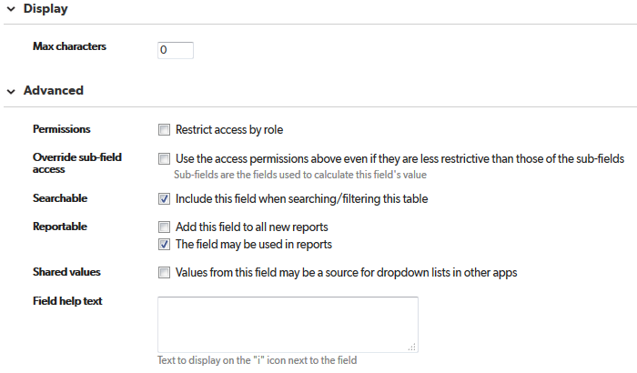

# Date to QA Internal

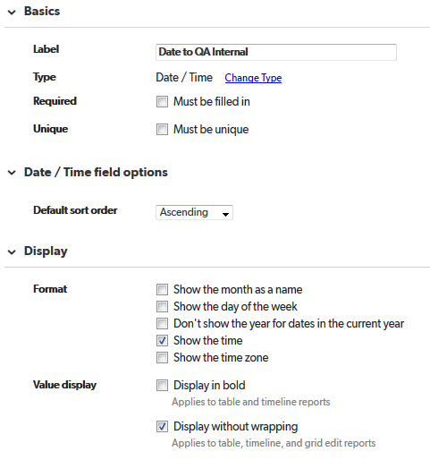

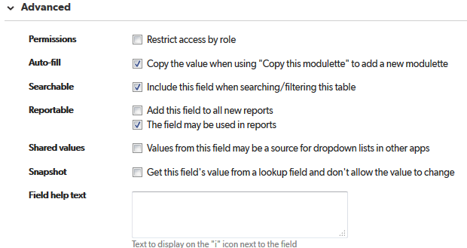

# Exclude from Search

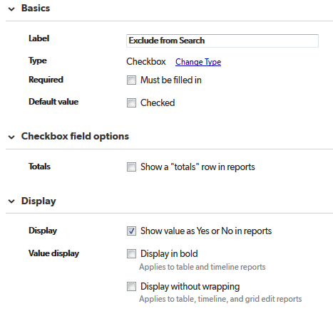

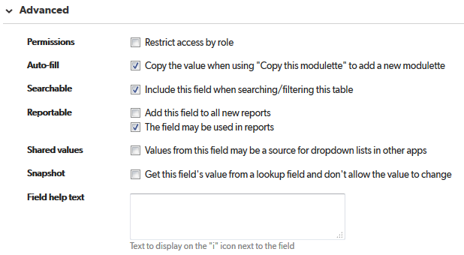

# exclude_words_from_search

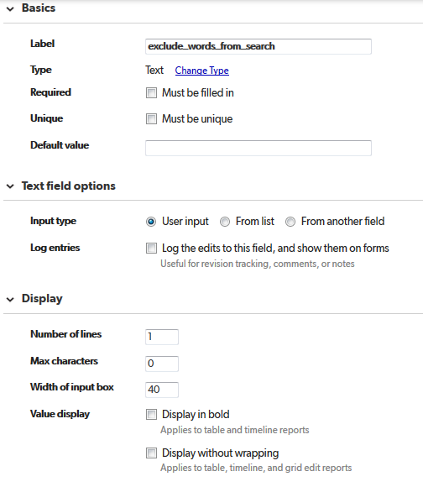

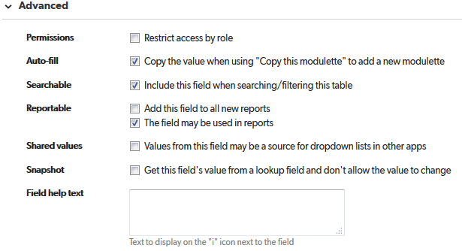

# hide_audio

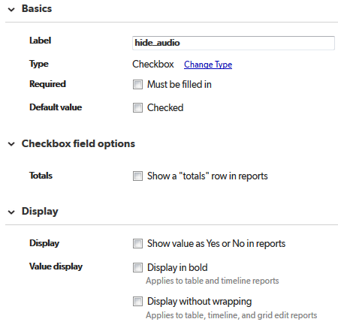

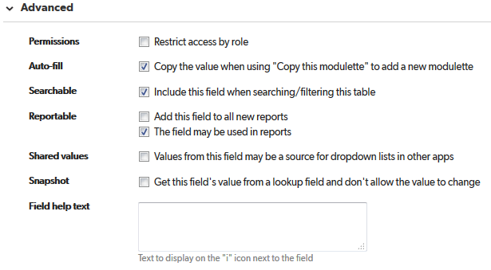

# hide_from_dashboard

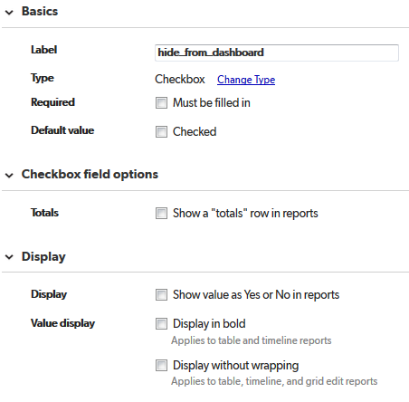

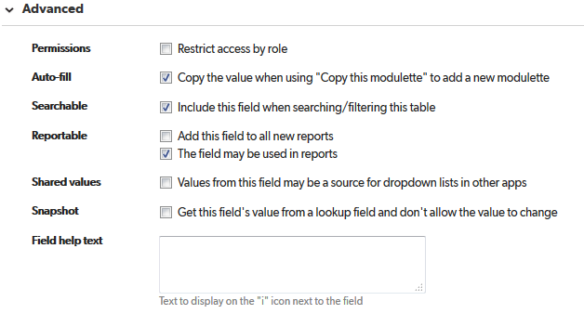

# hide_sub_audio

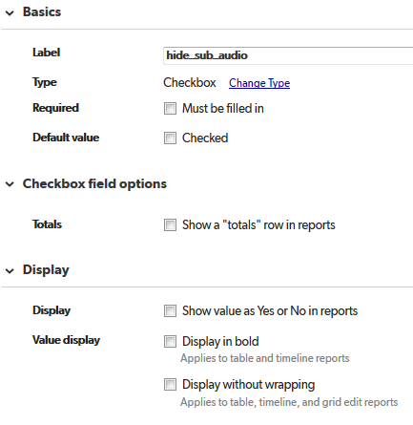

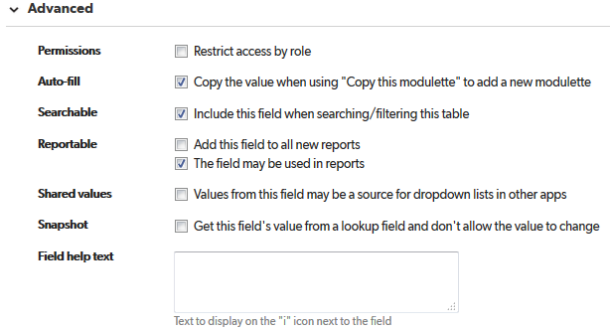

# Related modulette_group

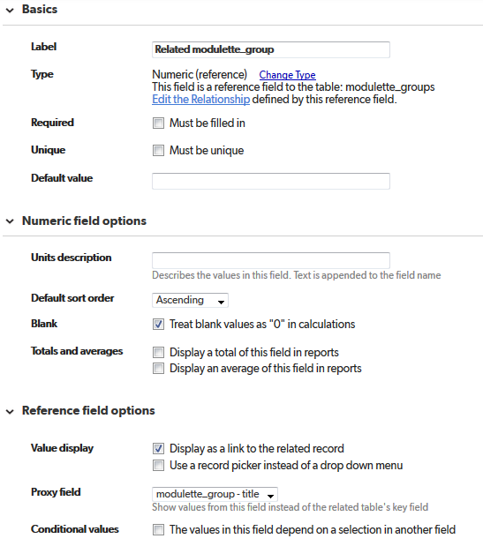

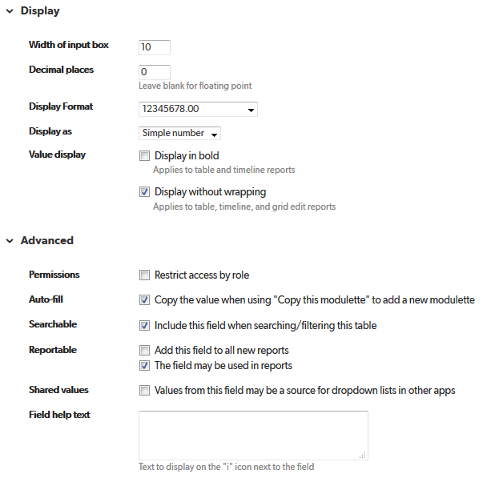

# related_module_id

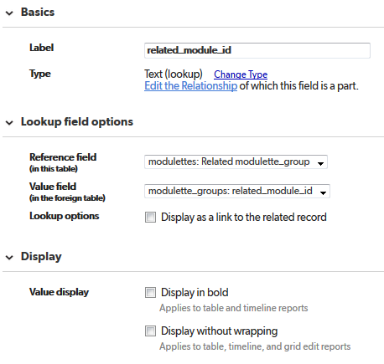

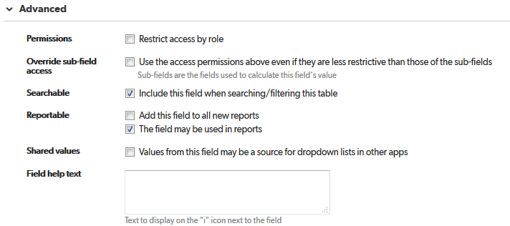

# tabs

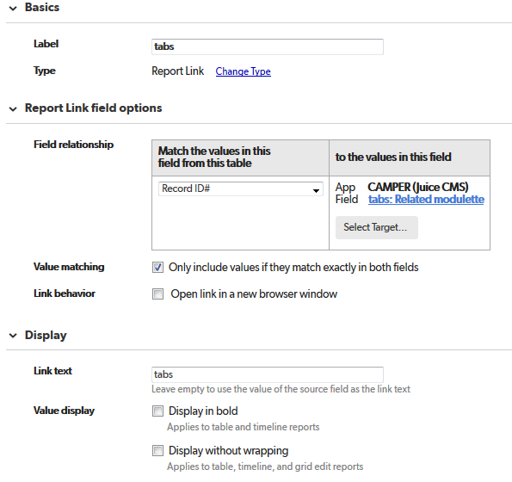

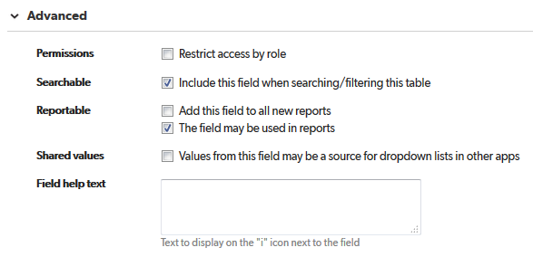

# Tags

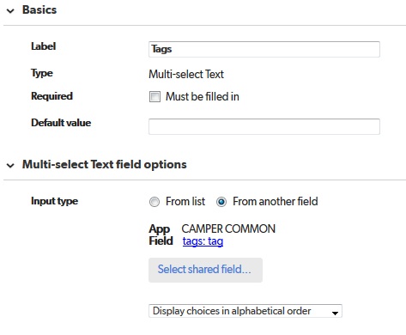

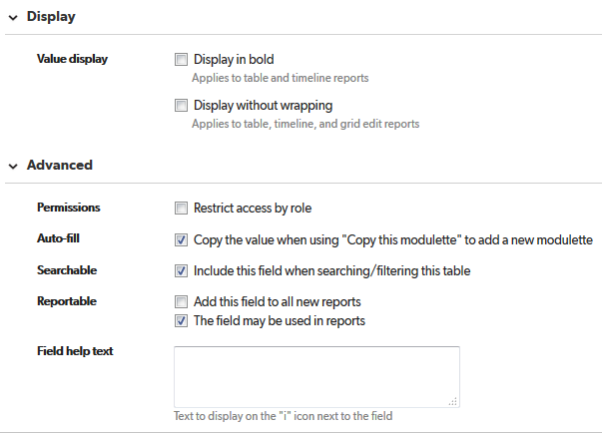

# Upload Date Internal

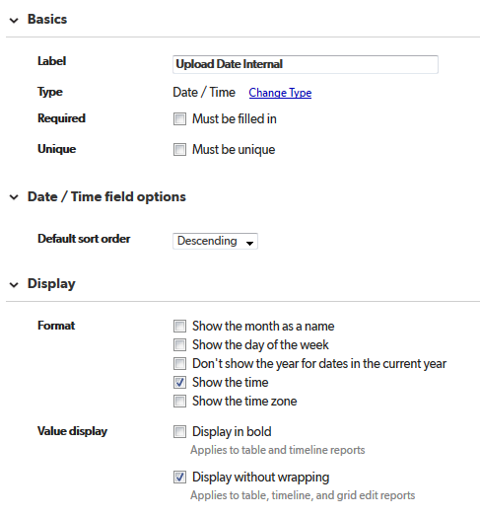

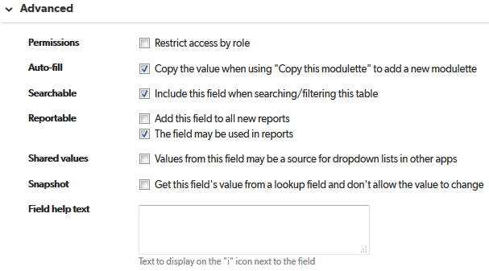

# related_module_title

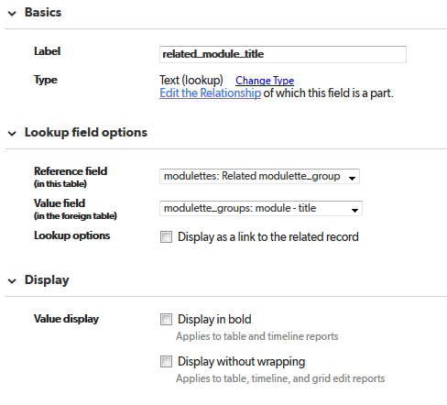

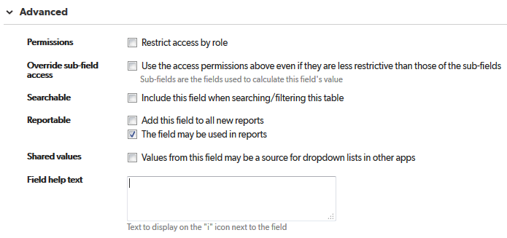

# Publish Date Internal

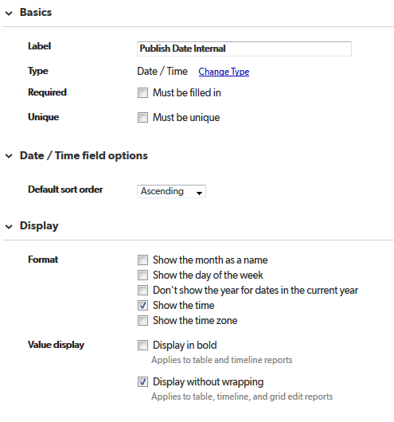

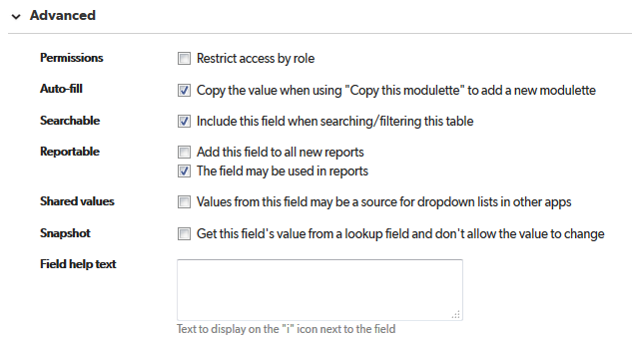

# Copy Date to QA Internal

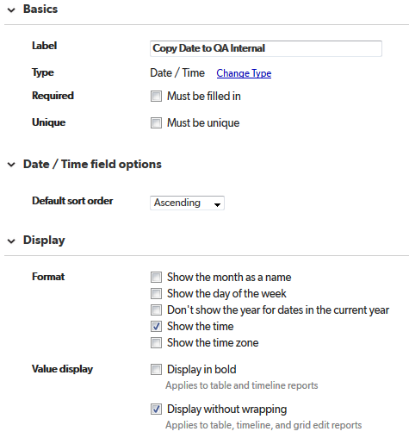

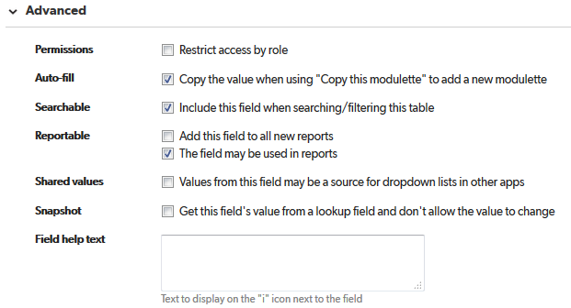

# Copy Date to PROD Internal

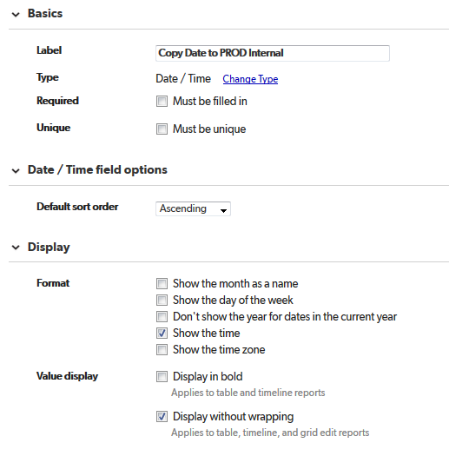

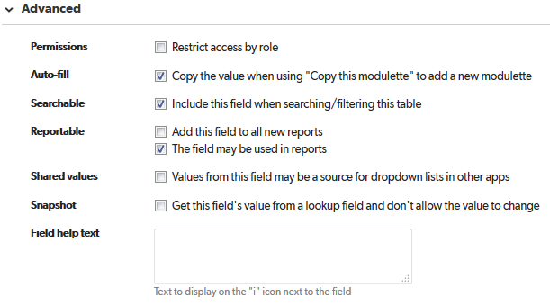

# Publish Date

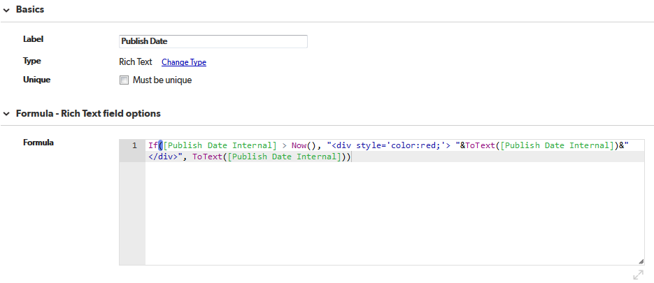

If([Publish Date Internal] > Now(), "<div style='color:red;'> "&ToText([Publish Date Internal])&"</div>", ToText([Publish Date Internal]))

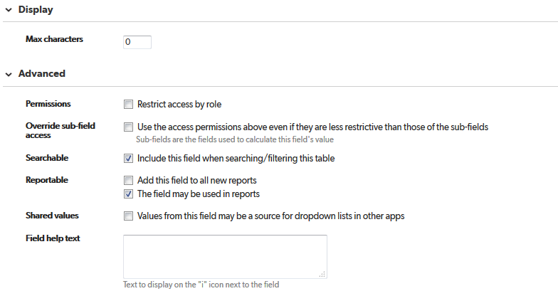

# Copy Date to QA

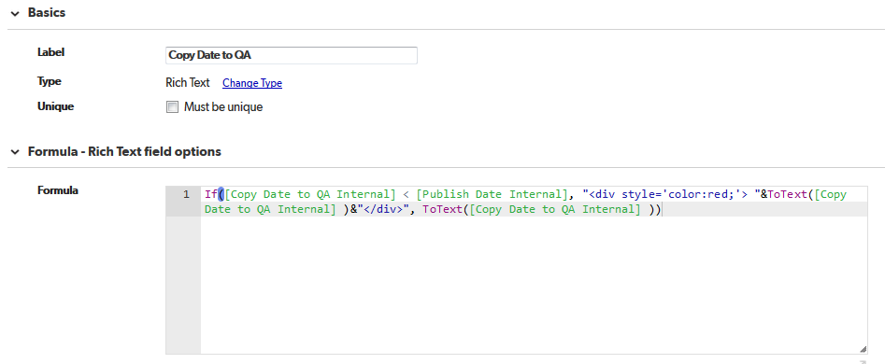

If([Copy Date to QA Internal] < [Publish Date Internal], "<div style='color:red;'> "&ToText([Copy Date to QA Internal] )&"</div>", ToText([Copy Date to QA Internal] ))

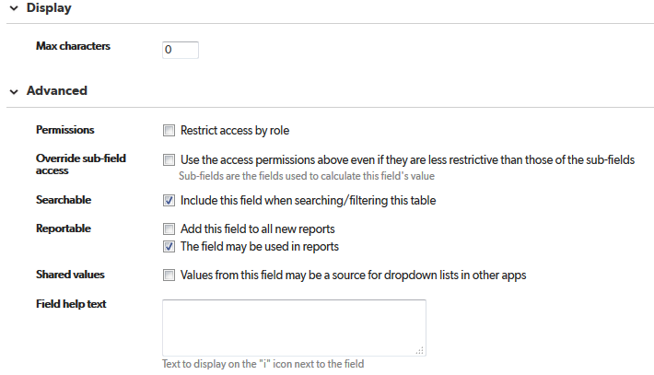

# Copy Date to PROD

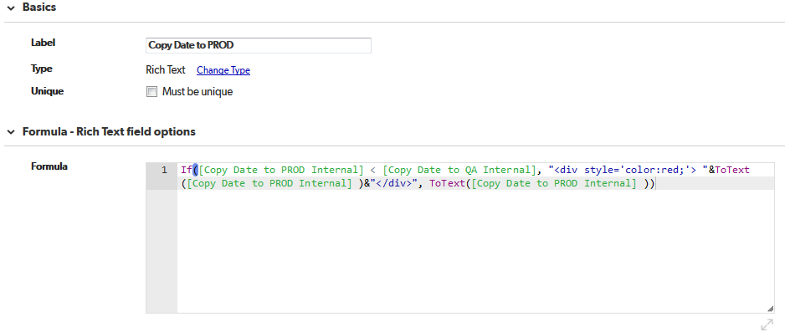

If([Copy Date to PROD Internal] < [Copy Date to QA Internal], "<div style='color:red;'> "&ToText([Copy Date to PROD Internal] )&"</div>", ToText([Copy Date to PROD Internal] ))

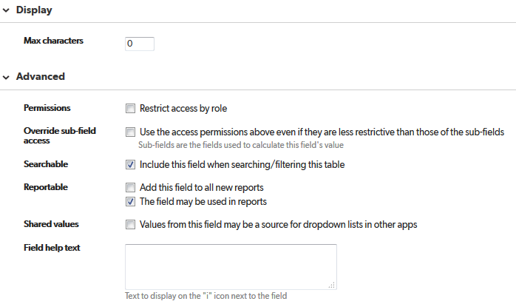

# Copy to QA

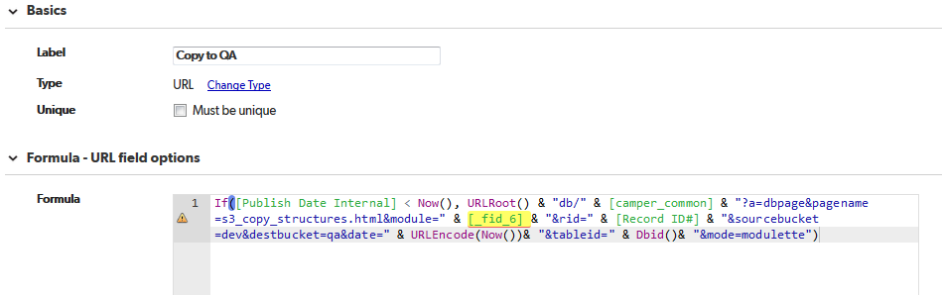

If([Publish Date Internal] < Now(), URLRoot() & "db/" & [camper_common] & "?a=dbpage&pagename=s3_copy_structures.html&module=" & [_fid_6] & "&rid=" & [Record ID#] & "&sourcebucket=dev&destbucket=qa&date=" & URLEncode(Now())& "&tableid=" & Dbid()& "&mode=modulette")

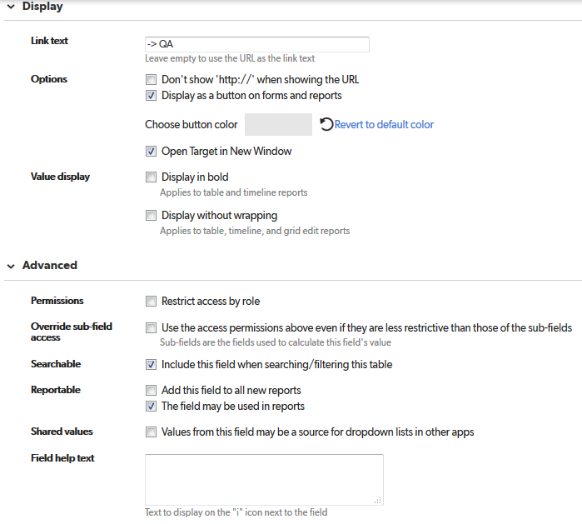

# Copy to PROD

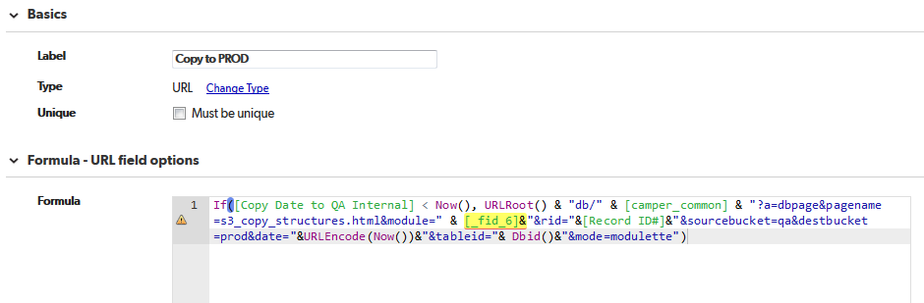

If([Copy Date to QA Internal] < Now(), URLRoot() & "db/" & [camper_common] & "?a=dbpage&pagename=s3_copy_structures.html&module=" & [_fid_6]&"&rid="&[Record ID#]&"&sourcebucket=qa&destbucket=prod&date="&URLEncode(Now())&"&tableid="& Dbid()&"&mode=modulette")

